**Experiment No.: 3**

**Aim**

Familiarization of linux commands

**CO2**

Perform system administration task

**Procedure**

1. pwd - Used to print the working directory.

After execution it shows the absolute path.

$pwd

2. ls - Used to list the files and content in the directory

$ls

**Output screenshot:**



i. ls -R – It list the directory as well as the subdirectory

$ls -R

**Output screenshot:**

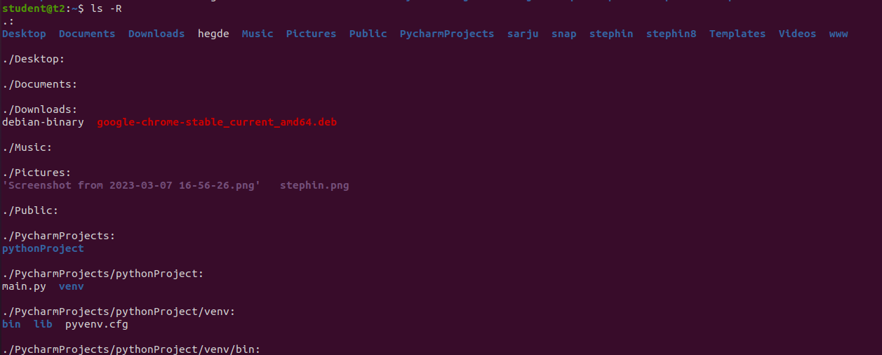

ii. ls -l – Used to view the long list of continue

$ls -l

**Output screenshot:**

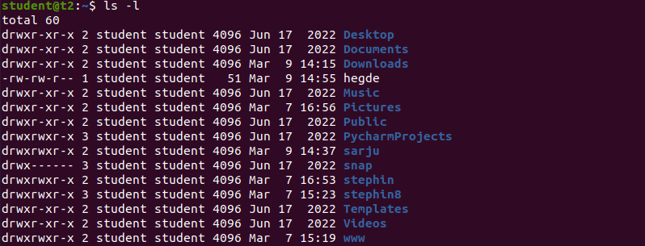

iii. ls -a – Used to view the list in directory along with hidden files

$ls -a

**Output screenshot:**



iv. ls – al -Used to view the list in directory with detailed information along with hidden files

$ls – al

**Output screenshot:**

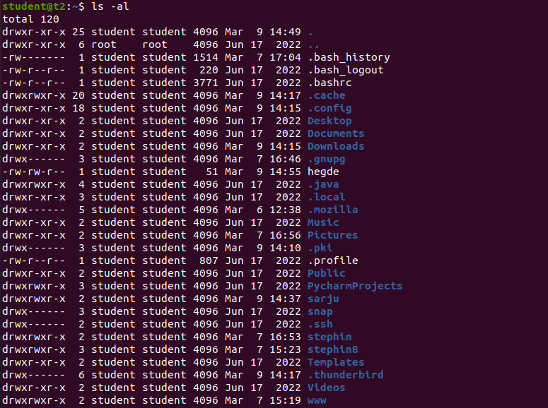

v. ls – t – Used to view the list in sorted order of last modified.

$ls – t

**Output screenshot:**



vi. ls – r – Used to view the list in reverse order of last modified.

$ls – r

**Output screenshot:**



vii. man ls – Used to learn and understand the existing commands we can learn and understand about different write from the shell using man command

$ man ls

**Output screenshot:**

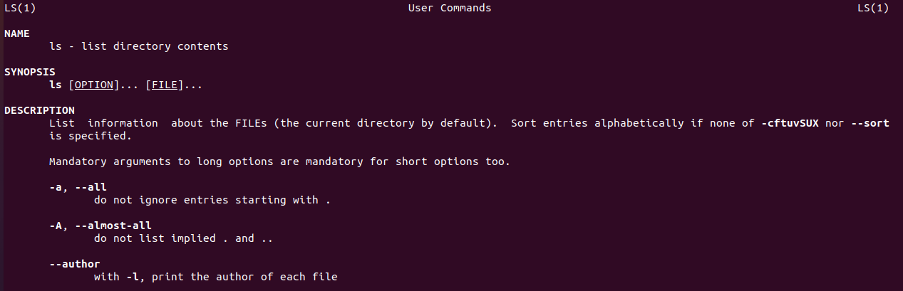

3. mkdir – Used to make new directory

$mkdir Edvin

**Output screenshot:**



4. cd – Used to navigate through the directory

$cd Edvin

**Output screenshot:**

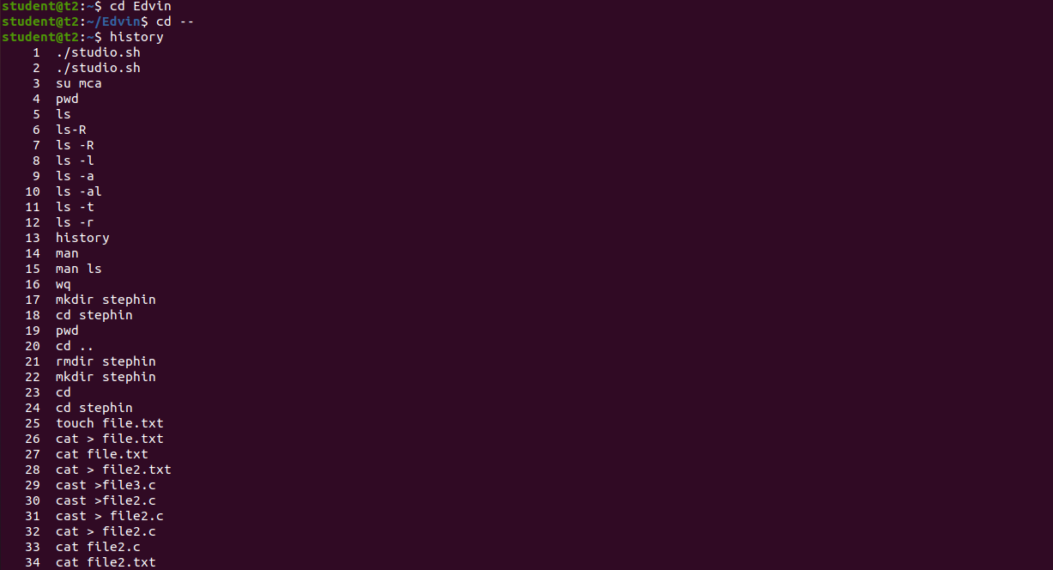

5. cd -- Used to move one directory up

$cd --

**Output screenshot:**



6. history – Used to view the list of commands executed in a certain period of time.

$ history

**Output screenshot:**



7. cat > - Used to create a new file

$cat > hegde

**Output screenshot:**

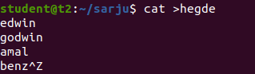

8. cat>> -Used to append content to an existing file

cat >> hegde

**Output screenshot:**

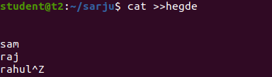

9. cat -n – Used to display content of file along with line number

$cat - n hegde

**Output screenshot:**

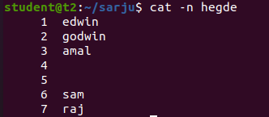

10. cat -b -Used to display content and number the lines that are not empty

$cat – b hegde

**Output screenshot:**

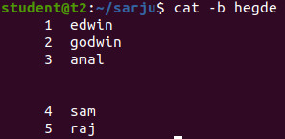

**Result**

The program was executed and the result was successfully obtained. Thus CO2 was obtained.